***Cd cmd command***

Description of the Command :

Displays the name of or changes the current directory.

CHDIR [/D] [drive:][path]

CHDIR [..]

CD [/D] [drive:][path]

CD [..]

.. Specifies that you want to change to the parent directory.

Type CD drive: to display the current directory in the specified drive.

Type CD without parameters to display the current drive and directory.

Use the /D switch to change the current drive in addition to changing the current directory for a drive.

• Some of the output is truncated due to its large length.

• In order to obtain the above text execute the cd /? command on cmd.

• It should be noted that chdir is an alias for cd, and therefore can be replaced for all of its occurrences.

Using the Command :

1. Displaying the Current Working Directory :

Displaying the current working directory is not generally not required on cmd. This is because the default prompt in cmd displays the Current drive and path (CWD) along with the greater than sign ( > ) at all times ($P$G code). But for the sake of completeness, we would be describing it as well. To display the Current Working Directory, execute the cd command without any arguments.

Syntax :

cd

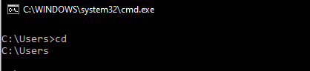

cd..

cd users.. **or** cd users

**c to d**

cd /d D:

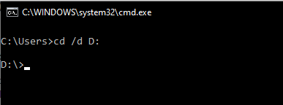

**D to c**

Cd /d C:

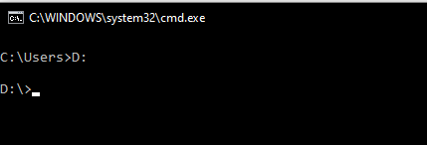

Let’s make long path

Current directory is

**D:\>**

Make long directory

**cd university\Web Notes\JavaScript**